Explainable AI in Pathology - Concept Based Explainability for Mitotic Figure Detection in Whole Slide Images.

Plain Language Statement

This study is being carried out as part of a Data Science final year project within the School of Computing, DCU. The student involved is Adam Tegart ([adam.tegart2@mail.dcu.ie](mailto:adam.tegart2@mail.dcu.ie)) and the supervisor for the project is Dr Alessandra Mileo ([alessandra.mileo@dcu.ie](mailto:alessandra.mileo@dcu.ie)).

This project concerns the investigation into how effective explainability methods based on visual concepts/features work for the use case of detecting mitotic figures. These concept-based explainability methods work by creating an understanding of what a visual concept is by using image examples, in this use case images of an abnormal cell membrane for example.

The motivation for carrying out this project is to understand how well this approach can be automated for this complex use case, eliminating the need to gather images that relate to a concept.

The participants will receive a questionnaire containing groups of images (sampled from the results) that were found through an automated approach and were found to be influential. They will be asked to determine if these groups of influential images relate to a visual concept that experts would typically use to identify a mitotic figure and select any images that do not fall within this concept.

The privacy of participants will be protected as no personal data or data that would allow for reidentification of the participant will be collected. The participants will be required to answer questions in a professional capacity only.

The collected data will be used as a guide for interpreting the results and understanding how well this automated approach can be applied.

The confidentiality of information provided cannot always be guaranteed by researchers and can only be protected within the limitations of the law - i.e., it is possible for data to be subject to subpoena.

The results of this survey will aid in determining the effectiveness of this method and will help to guide future research efforts in the area of explainable AI.

There are no perceived risks for participating in this study greater than the risks we encounter in everyday life.

Participation in this study is voluntary and consent can be withdrawn at any stage, resulting in the collected data being purged.

The findings from this project will be divulged to participants upon request and may additionally be published.

If participants have concerns about this study and wish to contact an independent person,

please contact:

The Secretary, Dublin City University Research Ethics Committee, c/o Research and Innovation Support, Dublin City University, Dublin 9. Tel 01-7008000, e-mail rec@dcu.ie

Informed Consent

School of Computing, DCU. Adam Tegart (Student), Dr Alessandra Mileo (Supervisor).

The purpose of this questionnaire is to gain insight into the results obtained during the course of the project from the perspective of an expert. The results of this questionnaire will help to quantify the efficiency of these methods for finding concepts automatically and ensure that they align with current knowledge within the field.

Quantifying and understanding the utility of the methods applied will allow for insights into future research ideas in the field and guide this future research.

I have read the plain language statement (or had it read to me)

I understand the information provided

I have had the opportunity to ask question and discuss the study

I understand the information provided in relation to data protection

I have received satisfactory answers to all my questions

I understand that I have the right to withdraw from the study at any stage

I understand that the confidentiality of the information provided is subject to legal limitations

I consent to participate in this study

The questions in this questionnaire are composed as follows:

* A grid of 30 images (segments of annotations) that have been sampled from a group that is found to be influential are displayed along with the context image (complete image, zoomed out for context) to help see where the segment is in relation to the mitotic figure.
* You will be asked if these images (or most of at least) represent some visual feature of a mitotic figure. Please try to be as descriptive as you can.
* You will then be asked if any of the images don’t belong in the grouping, meaning an image does not represent the concept that this group should supposedly be representing.

The images in the grid are indexed from 0-29, and these can be used to reference images that do not belong in a set. There is a black box on the context image that represents the original annotation. The image was segmented at the level of the original annotation and at the context level (zoomed out). The motivation was to capture the different levels of visual features, such internal cell features in the annotation and the position in relation to nearby cells in the context.

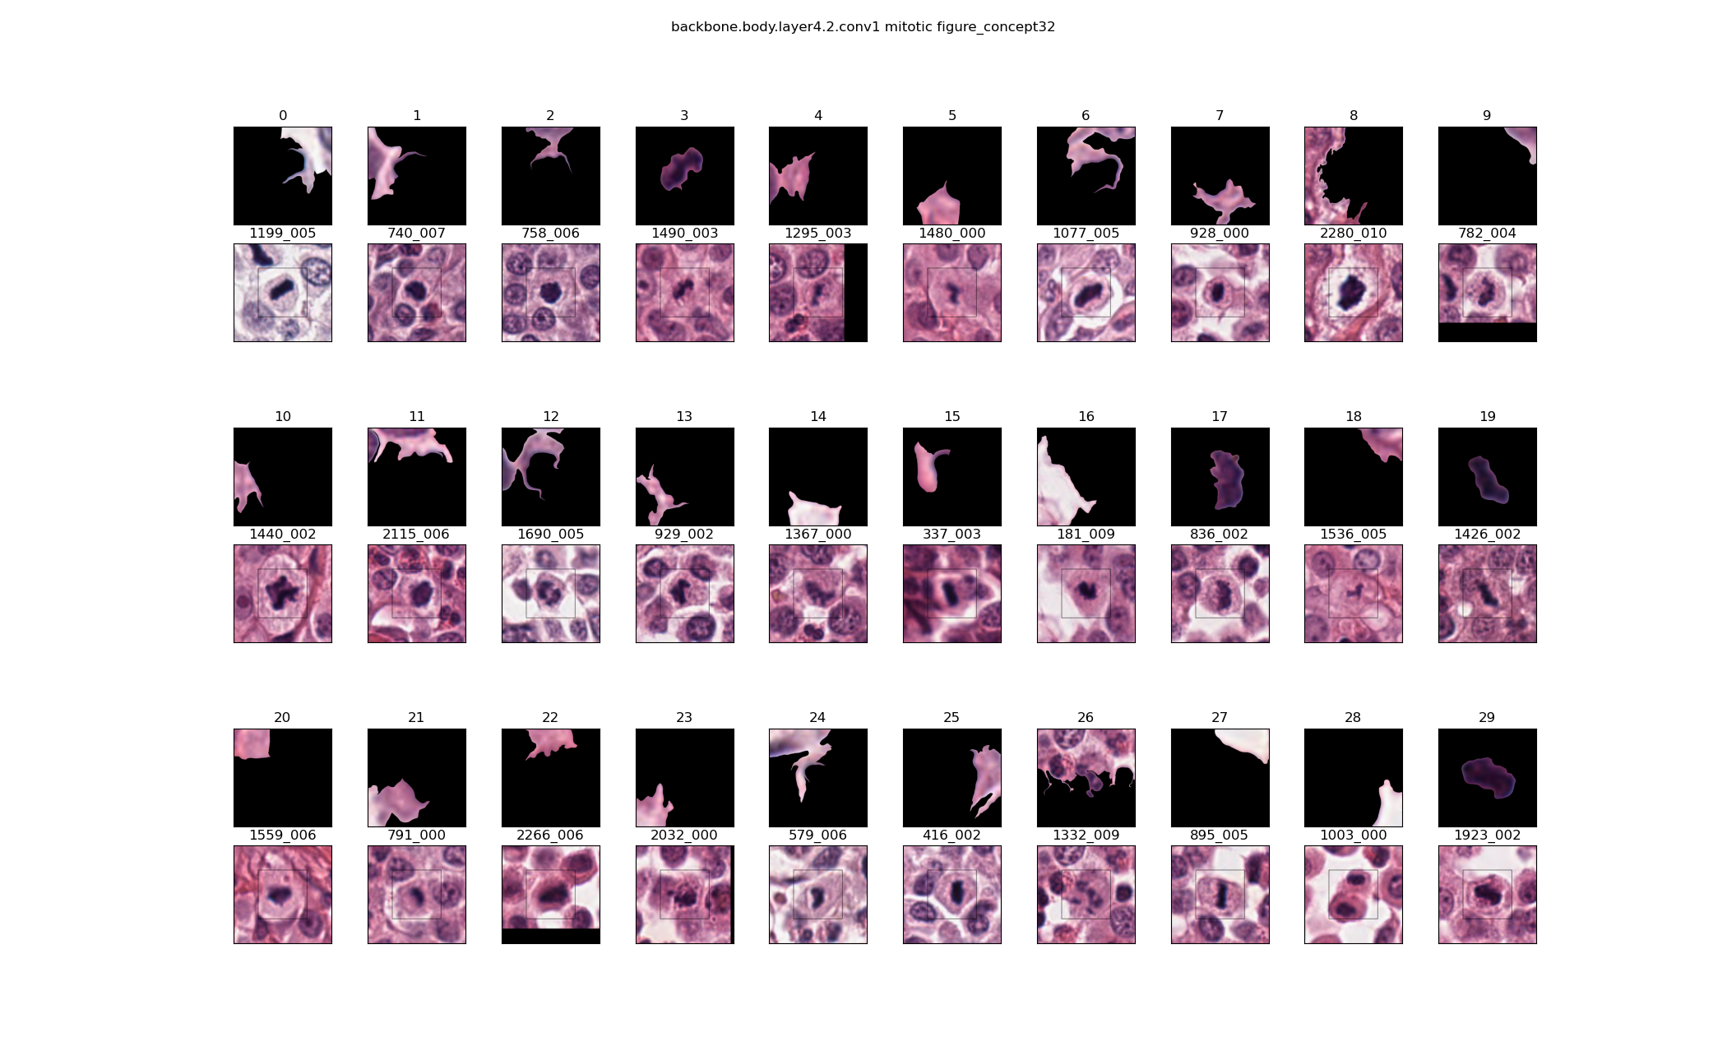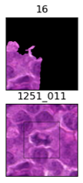The patch segment can be found in the context image by matching it against the annotation (inner) or context box (outer), the example below shows an annotation segment, which can be found at the top right of the inner/annotation box. The image index (1199_005 below) captures the annotation index (1199) and segment index (005). If the segment index is 9 or larger the segment is likely a context one (zoomed out), so is shown in relation to the outer box.

Fig1. Example of an annotation segment (within inner box). Fig2. Example of a context segment (can contain annotation).

This will be carried out for 4 different tissue types, totalling 10 concepts:

* Canine Lymphoma – 5 concepts
* Canine Cutaneous Mast Cell Tumour – 2 concepts
* Canine Lung Cancer – 1 concept
* Human Neuroendocrine Tumour – 2 concepts

Q1. Could you describe the visual features that are typically used to identify a mitotic figure?

Canine Lymphoma

Q2a.

Is there any visual feature that these images (or most of) represent? If not, is there any pattern visible?

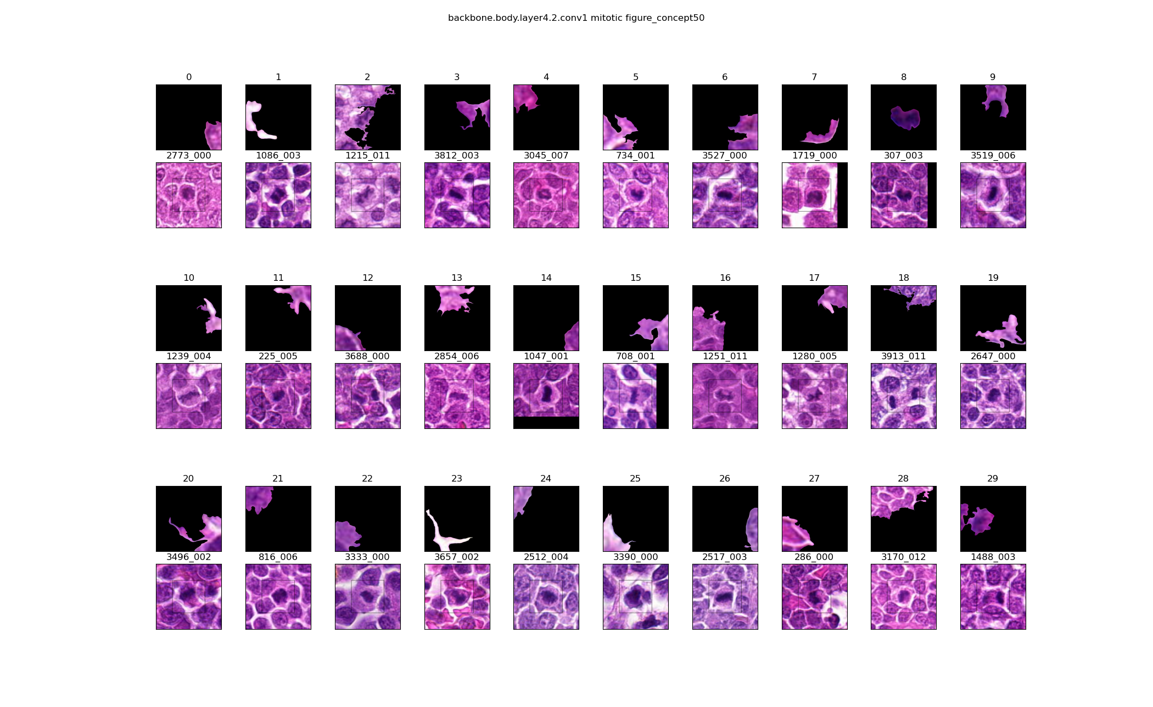Please answer below.

Q2b.

Are there any images in the above group that are not representative of this feature/concept? Please give the grid index and briefly explain.

Canine Lymphoma

Q3a.

Is there any visual feature that these images (or most of) represent? If not, is there any pattern visible?

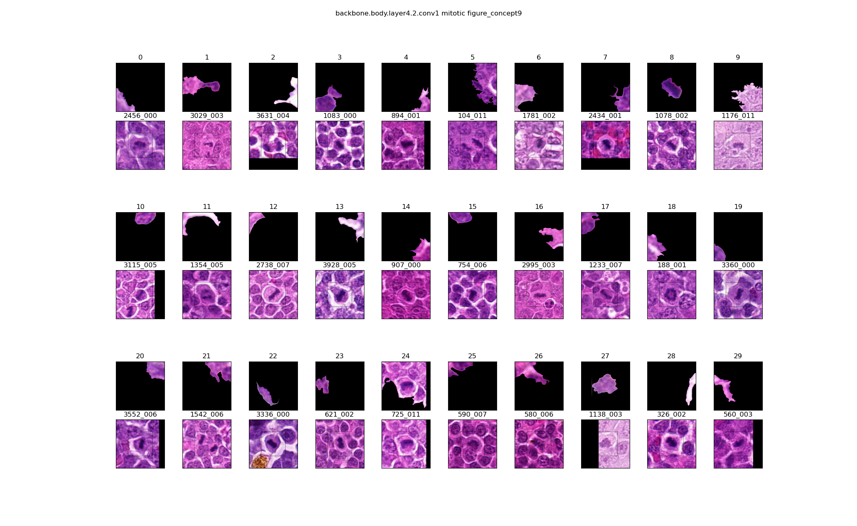Please answer below.

Q3b.

Are there any images in the above group that are not representative of this feature/concept? Please give the grid index and briefly explain.

Canine Lymphoma

Q4a.

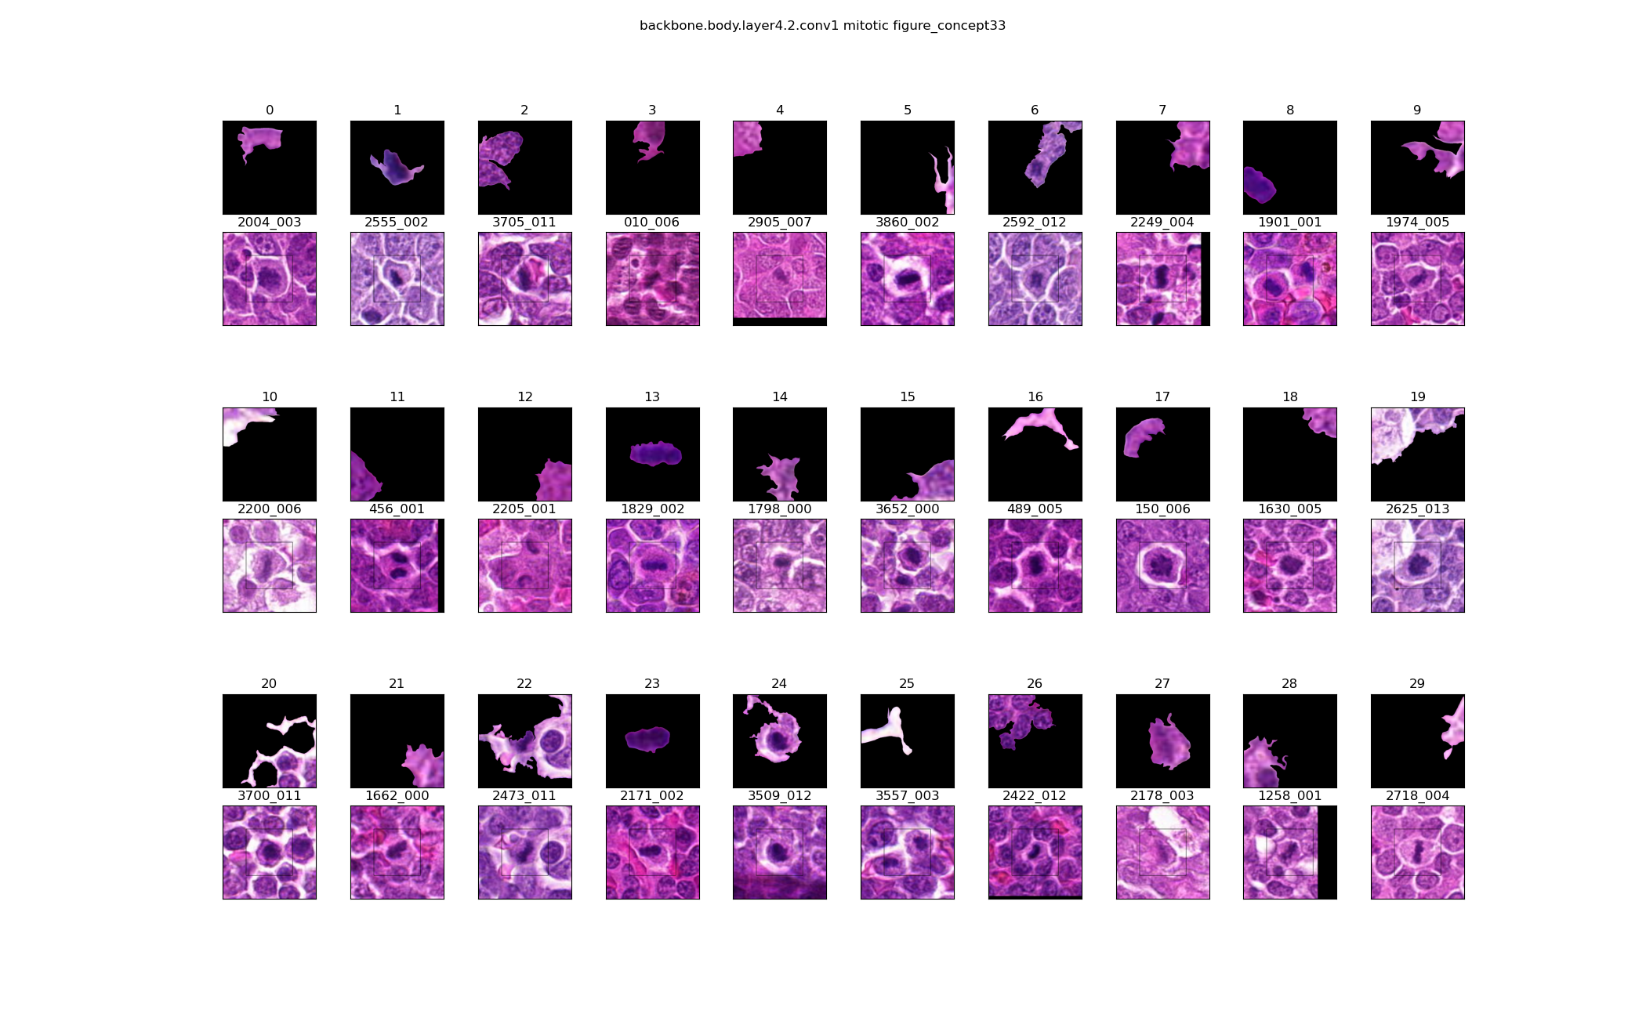Is there any visual feature that these images (or most of) represent? If not, is there any pattern visible?

Please answer below.

Q4b.

Are there any images in the above group that are not representative of this feature/concept? Please give the grid index and briefly explain.

Canine Lymphoma

Q5a.

Is there any visual feature that these images (or most of) represent? If not, is there any pattern visible?

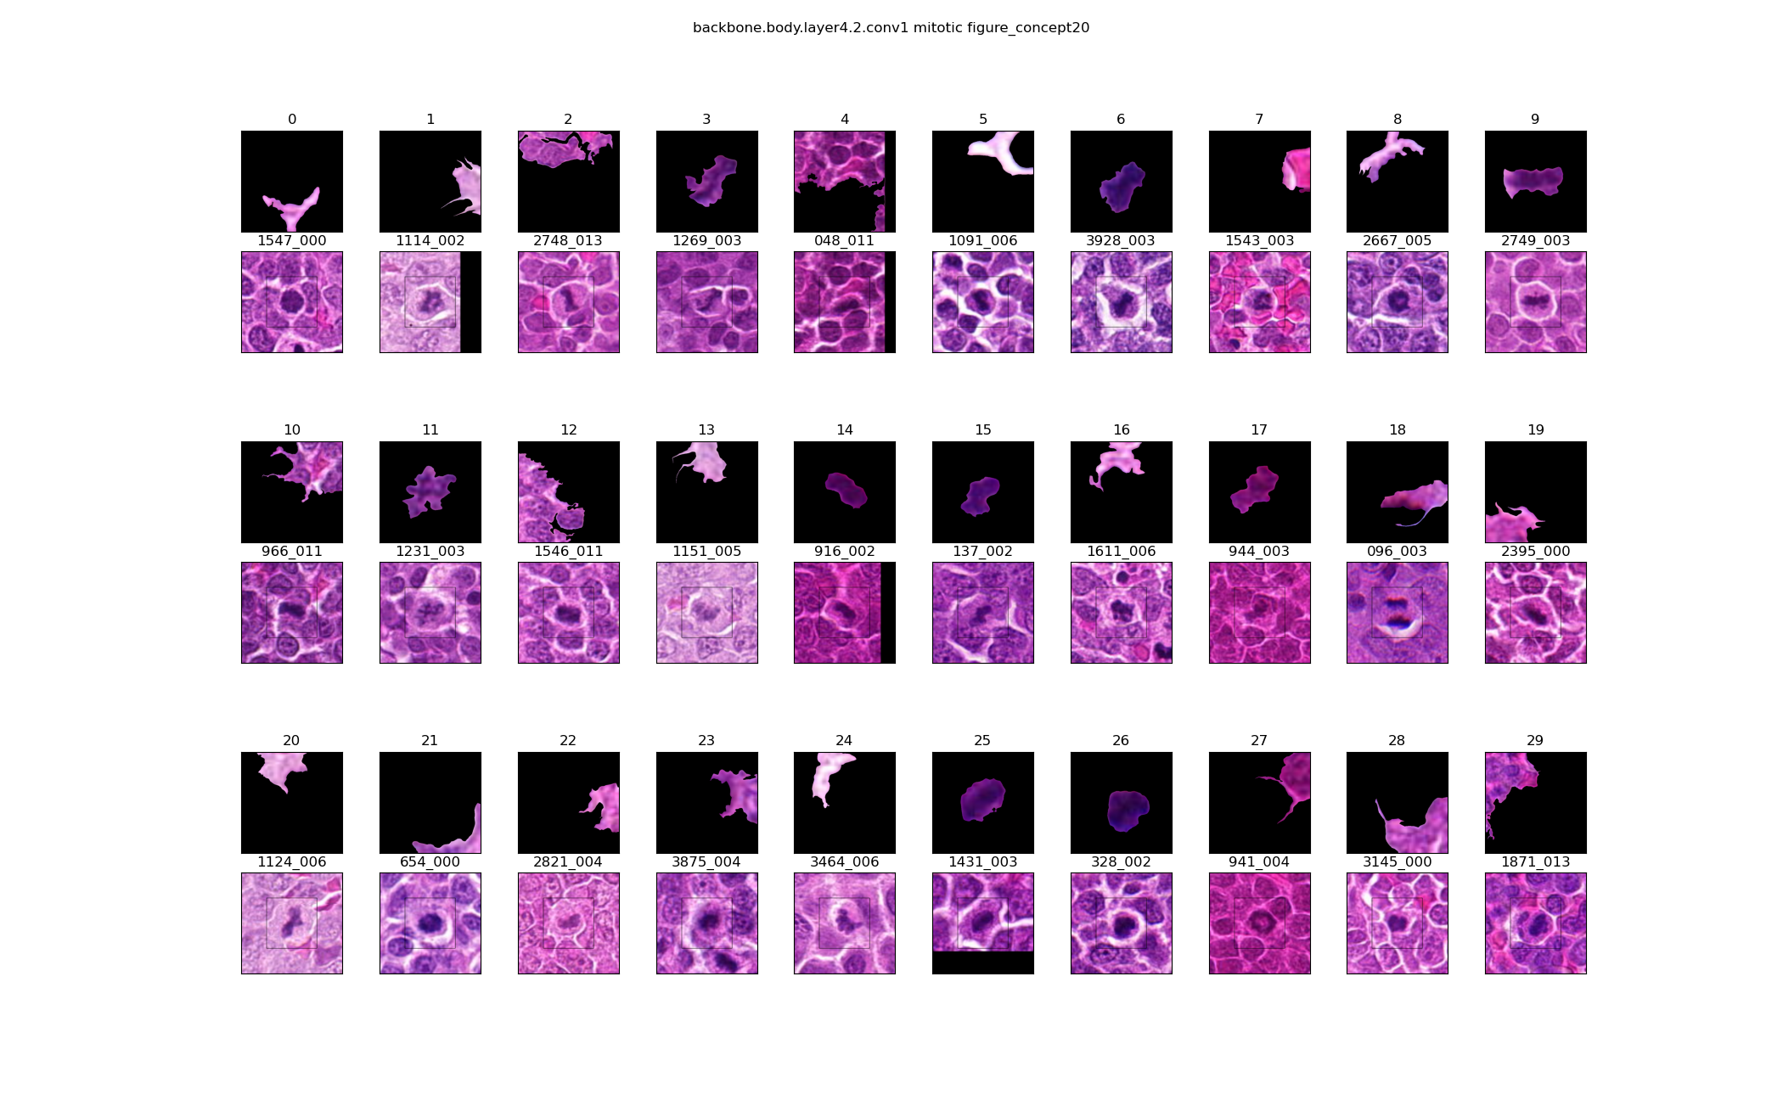Please answer below.

Q5b.

Are there any images in the above group that are not representative of this feature/concept? Please give the grid index and briefly explain.

Canine Lymphoma

Q6a.

Is there any visual feature that these images (or most of) represent? If not, is there any pattern visible?

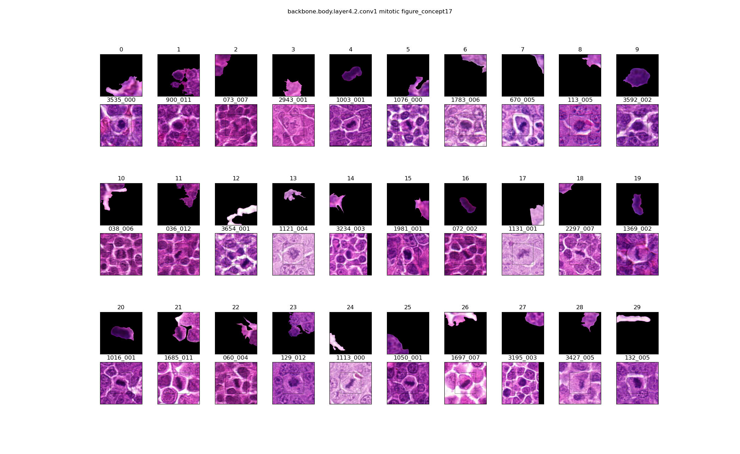Please answer below.

Q6b.

Are there any images in the above group that are not representative of this feature/concept? Please give the grid index and briefly explain.

Canine Cutaneous Mast Cell Tumour

Q7a.

Is there any visual feature that these images (or most of) represent? If not, is there any pattern visible?

Please answer below.

Q8b.

Are there any images in the above group that are not representative of this feature/concept? Please give the grid index and briefly explain.

Canine Cutaneous Mast Cell Tumour

Q8a.

Is there any visual feature that these images (or most of) represent? If not, is there any pattern visible?

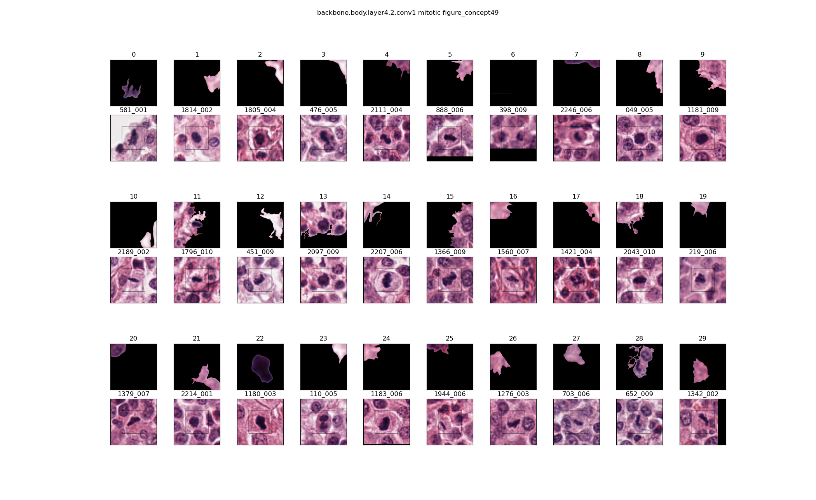Please answer below.

Q8b.

Are there any images in the above group that are not representative of this feature/concept? Please give the grid index and briefly explain.

Canine Lung Cancer

Q9a.

Is there any visual feature that these images (or most of) represent? If not, is there any pattern visible?

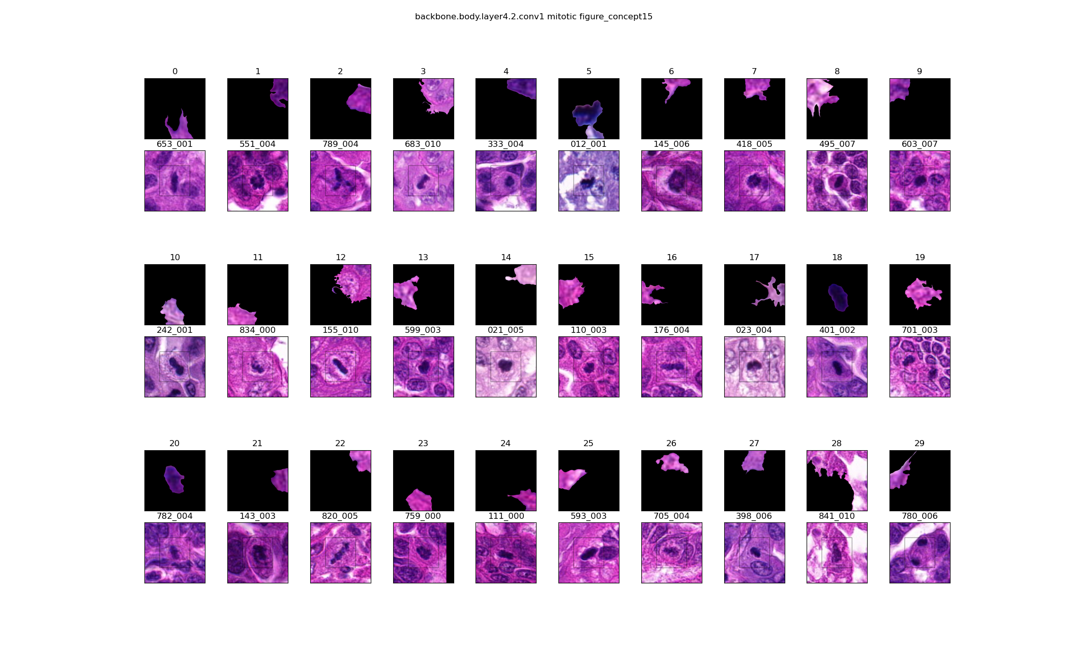Please answer below.

Q9b.

Are there any images in the above group that are not representative of this feature/concept? Please give the grid index and briefly explain.

Human Neuroendocrine Tumour

Q10a.

Is there any visual feature that these images (or most of) represent? If not, is there any pattern visible?

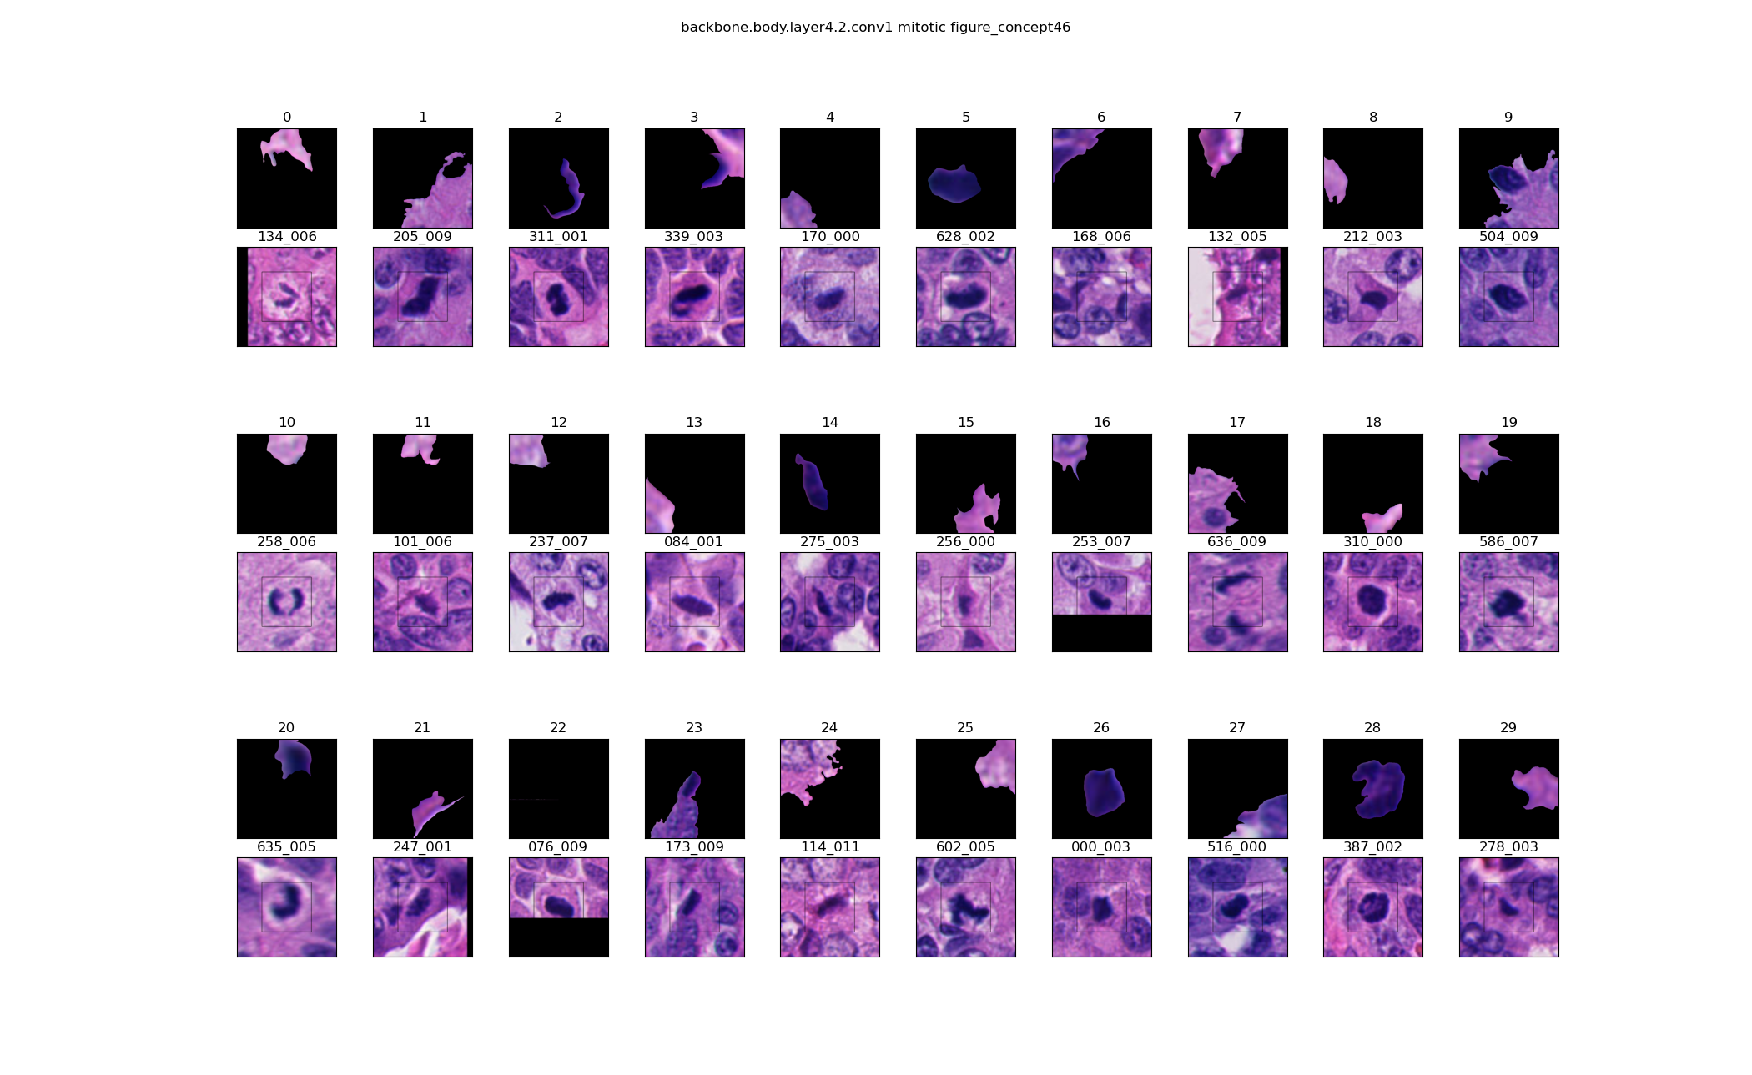Please answer below.

Q10b.

Are there any images in the above group that are not representative of this feature/concept? Please give the grid index and briefly explain.

Human Neuroendocrine Tumour

Q11a.

Is there any visual feature that these images (or most of) represent? If not, is there any pattern visible?

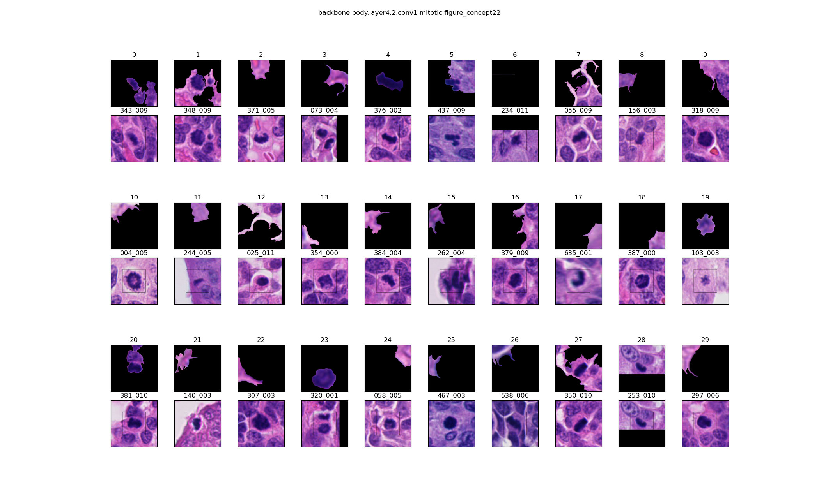Please answer below.

Q11b.

Are there any images in the above group that are not representative of this feature/concept? Please give the grid index and briefly explain.

This is the end of questionnaire. Thank you for taking the time to review these results!